WOODMONT UNITED CHURCH OF CHRIST

MINISTERS: All Members
PASTOR: The Rev. Jill E. Olds
DEACON TO ASSIST: Barbara Mackintosh
MUSIC: Bruce Barrett

January 23, 2022
Third Sunday after Epiphany
* Please rise in body or spirit
**Indicates gender neutral wording

PRELUDE MUSIC

GREETING AND WELCOME

INTROIT “Sanctuary”
Words: “Lord prepare me to be a sanctuary, pure and holy, tried and true.
With thanksgiving, I’ll be a living sanctuary for You.”
(John W. Thompson, Randy Scruggs 1982 Full Armor Publishing Company CCL# 20029017)

CALL TO WORSHIP

One: There are different kinds of spiritual gifts, but the same Spirit gives them.
Many: There are different ways of serving, but the same God is
served.
One: There are different abilities to perform service, but the same
God gives ability to each of us for our particular service.
Many: The Spirit’s presence is show in some way in each person for the good of all.
One: Come, let us celebrate the Spirit’s presence in and amongst us. Come, let us worship God!

HYMN #55 “Rejoice, You Pure In Heart”

PRAYER OF INVOCATION (unison)
O Living God, who was, who is, and who is to come, you have gifted us each uniquely, beyond what we could ever ask for or imagine, so that we might in turn use our gifts to serve you and our world. Grant us eyes to see and ears to hear how we might use those gifts together as the church, honoring each one as having come from you. Kindle the flame of your Spirit within our hearts, so that we can also tend our fiery Spirit by looking ahead to the future of our mutual ministry, and where it will spread. We pray all of these things in the strong name of Jesus, Amen.

GLORIA PATRI

PRAYER OF CONFESSION
Holy God, if we reflect inwardly upon our spirits, we become all too aware of the less-than-desirable pieces that lie within us. We forget your loving compassion for us, and thus forget to be loving towards ourselves, and towards others. In the midst of our busy existences, we are prone to forget that all we do is not meant to be polished or perfect, a false veneer of having it all together; rather, all we do is meant to be a reflection of you, a mirror of your love and acceptance shining outwardly for all to see. Help us have fresh eyes, God, so that might see our world and our actions in it the way you do, through eyes of compassion and wholeheartedness. It is in Your Name we pray, Amen.

ASSURANCE OF PARDON

ANTHEM

SCRIPTURE 1 Corinthians 12: 1-31a

SERMON "Teams and Work”

PASTORAL PRAYER

INVITATION TO OFFERING AND DOXOLOGY

PRAYER OF DEDICATION

God of the greatest gifts, of love and life and joy and peace: may we embrace such things, and then as a gathered Body, live them out for all the world to see. Thank you for your gifts, and please take ours, to do with according to your will in this world. Amen.

PARISH ANNOUNCEMENTS

HYMN #401 "O God in Whom All Life Begins"

THE BENEDICTION
The CONGREGATIONAL RESPONSE

POSTLUDE

Woodmont
United Church
of Christ
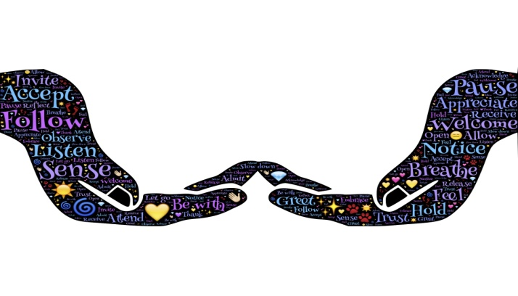

Our Vision Statement
Woodmont United Church of Christ embodies God’s
unconditional love by ministering to the needs of
people and the environment, striving to promote
spiritual growth through scripture-driven,
exuberant worship and advocating for peace and justice.

We celebrate diversity and welcome all into a fellowship of
acceptance, forgiveness, spiritual exploration, and discovery.

IN OUR PRAYERS
Nancy Hall; Joanna; the family of Mike Attruia (Carol’s brother in-law) at his passing; Julia Attruia Williams (Carol’s niece); Lori Masters (a friend of Dorothy); John Standeiner (Dorothy Osanitsch's cousin); Betty (Deb Mason’s mom); Betty (Wendy Cahill’s mom); Kelly (Art and Ann’s neighbor); Jecy (Ann Yost’s godson); Tracy; all those who are suffering from the many effects of Covid; medical workers and emergency personnel; all those impacted by natural disasters; those serving in the military; those suffering or recovering from addictions; the unemployed or under-employed; the homeless; those in prison; those suffering emotional illness; those suffering religious persecution; peacemakers; the staff and churches of the Southern New England Conference UCC; and our elected leaders.

ANNUAL MEETING - Save the Date!
Our Annual Meeting will be held on Sunday January 30th at noon, most likely on Zoom. This meeting is an opportunity for you to participate in the ministry of WUCC. The 2022 budget will be presented and voted on. All the Officers, Boards and Committees will be announced and there will be a chance for members of the congregation to volunteer to join one of these groups.
We must have a quorum to be able to vote, so your attendance is critical. Please make every effort to attend and participate. See the weekly bulletins and the Woodmont Weekly for details regarding whether the meeting will be in-person or on Zoom.

Mission Update - The Purple Pantry Box is replenished every Monday our church members and the rest of days of the week by Milford’s Purple Pantry community. If you want to supplement what your Mission Team at church is doing to fill the box on Mondays, bring your items in and place them in the plastic container marked “Purple Pantry” (outside the red front doors).

Weekly Calendar
Jan. 24th – 1:30 pm – Regathering Team Meeting
Jan. 30th – Noon – ANNUAL MEETING on Zoom!!!

Woodmont United Church of Christ
“No matter who you are, or where you are on life’s journey,
you are welcome here.”
1000 New Haven Avenue, Milford, CT 06460 Phone: 203-878-3885
Email: woodmontucc@optimum.net
Visit our website: http://www.woodmontucc.org
Follow us on Facebook, Twitter, and Instagram!

